VOICE ASSISTANT

**BACHELOR OF ENGINEERING IN**

**COMPUTER SCIENCE & ENGINEERING**



**SUBMITTED TO:-**

**ASS.PRO. Randeep Kuar**



**Guided by: Er. Shweta Agarwal**

**SUBMITTED BY :-**

**SUMIT KUMAR (18BCS6654)**

**ADITYA ARORA(18BCS6656)**

**SHIVAM BADONIYA(18BCS3054)**

**BINIT KUMAR SINGH (18BCS6639)**

**DEPARTMENT OF COMPUTER SCIENCE & ENGINEERING**

**Chandigarh University, Gharuan**

**Implementation**

There will be a total of 8 major tasks in this project. The modules are as explained below:

* **Listening to the user's command**– Defining a function to record the audio command of the user and printing it on the screen also. For this I used **speech recognition** library of python. This converts spoken text into python strings.
* **Get a response from the assistant** – Defining a function to make the assistant respond by speaking back to the user. This function uses the **google text to speech(gTTS)** library to convert the assistance response in audio form.

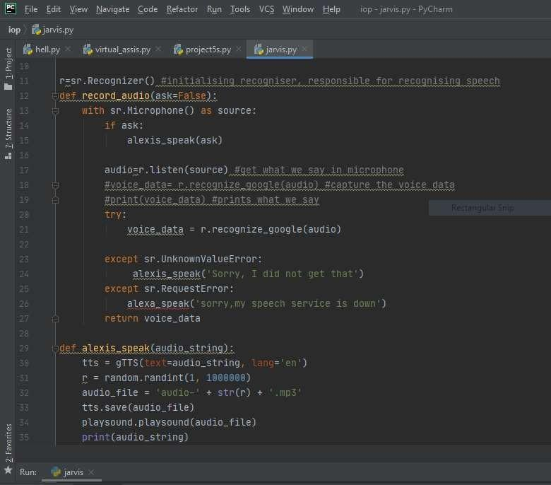

* **Greeting the user and telling the date and time** – Responding with greetings How may I help when the program is started. If the user asks what time is it it will respond with the exact date and time at that moment. This uses **ctime** function to get the time.

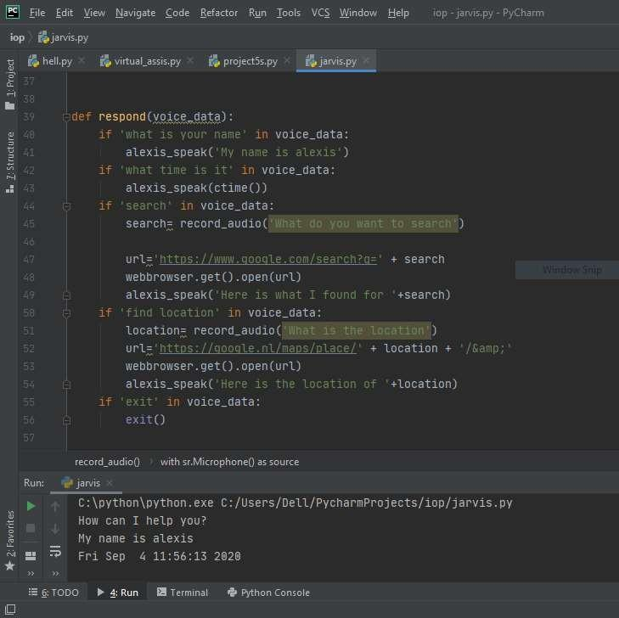

* The main function – This function contains trigger words that will make the assistant perform the required task. The tasks are:
  + **Searching the web** – If there is a search word in the user's statement the assistant will ask back what the user wants to search for and then opens the web browser and make the required query. This uses the **webbrowser** library to make the required search.

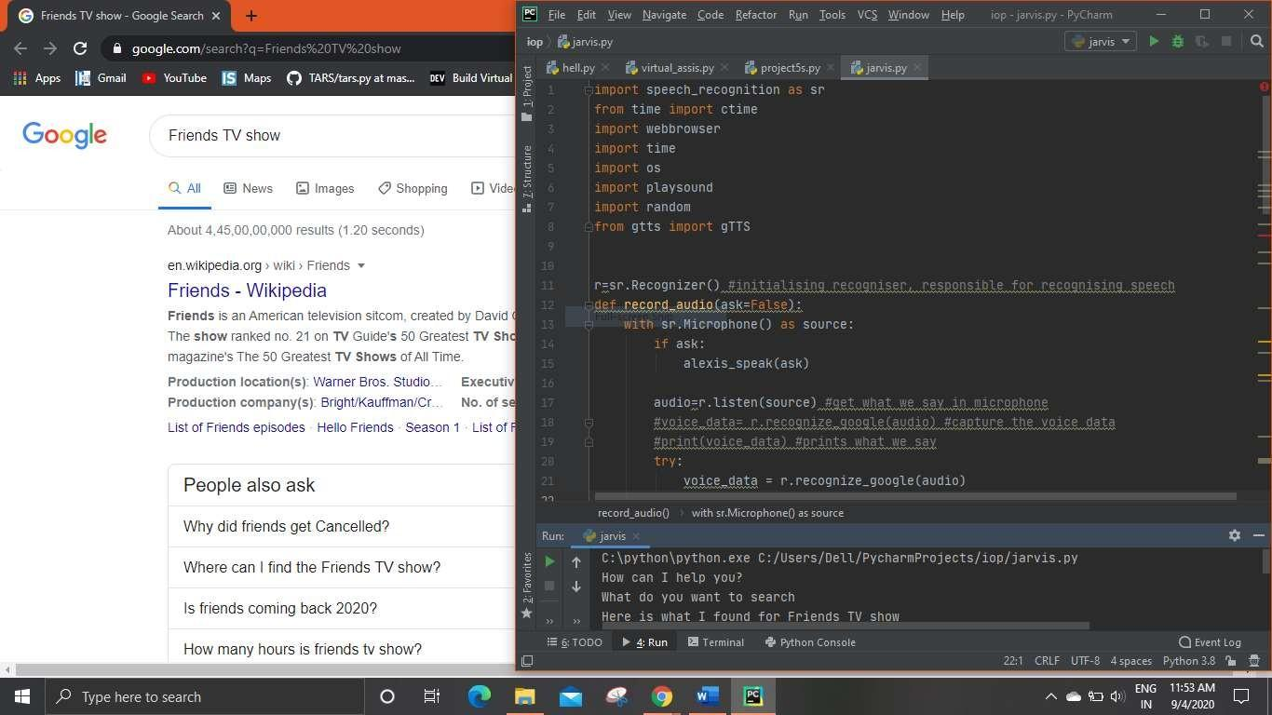

* + **Searching location**- – If there is a search location word in the user's statement the assistant will ask back what is the location the user wants to search for and then opens the google maps to show the location. This also uses webbrowser library to find the location.

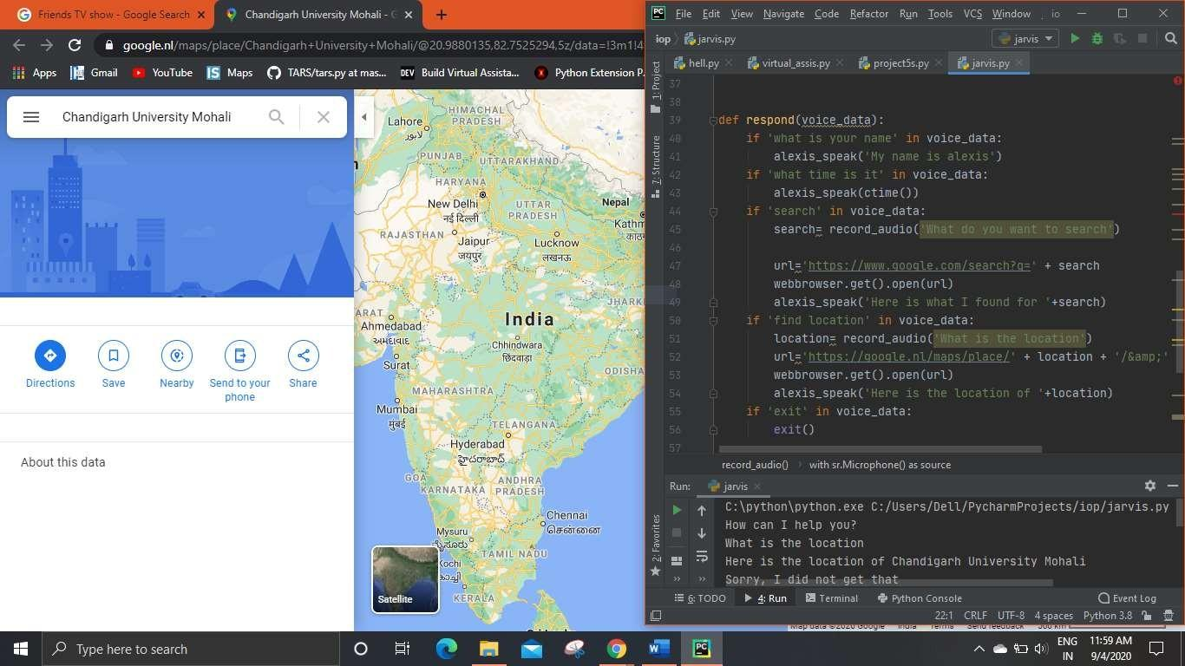

* + **Sending email** – If the user gives a command to send an email the assistant will ask for the subject and the body and then send the email to the required recipient. The **smtplib** library was used to implement this module.

The **smtplib** module defines an SMTP client session object that can be used to send mail to any Internet machine with an SMTP or ESMTP listener daemon

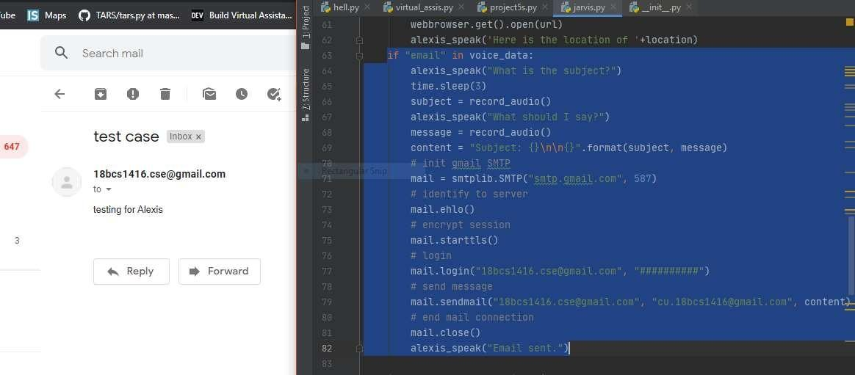

* + **Opening YouTube** – If the user asks for YouTube video the assistant opens the YouTube and then searches the query and plays the first video available on the list..

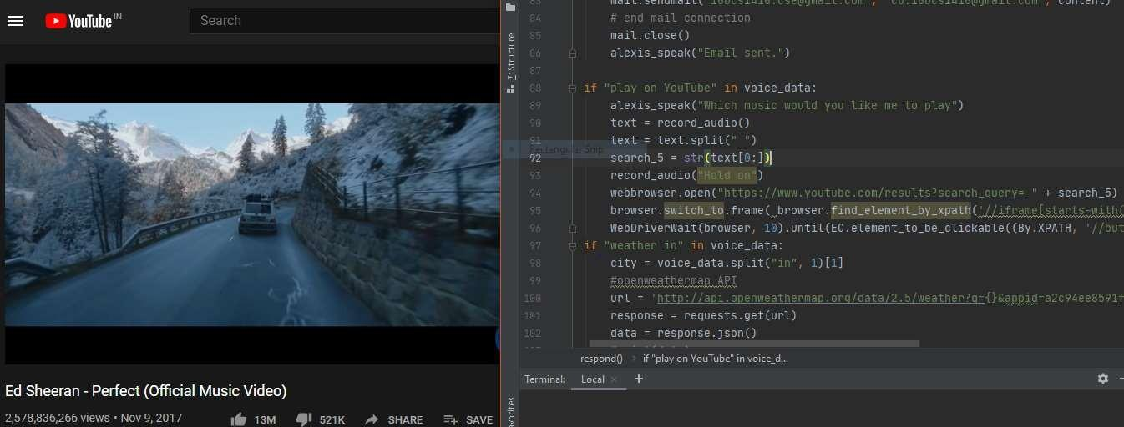

* + **Telling about the weather**- If the user asks about the weather the assistant tells the weather condition. **openweathermap** is a service that provides weather data, including current weather data, forecasts, and historical data to the developers of web services and mobile applications.

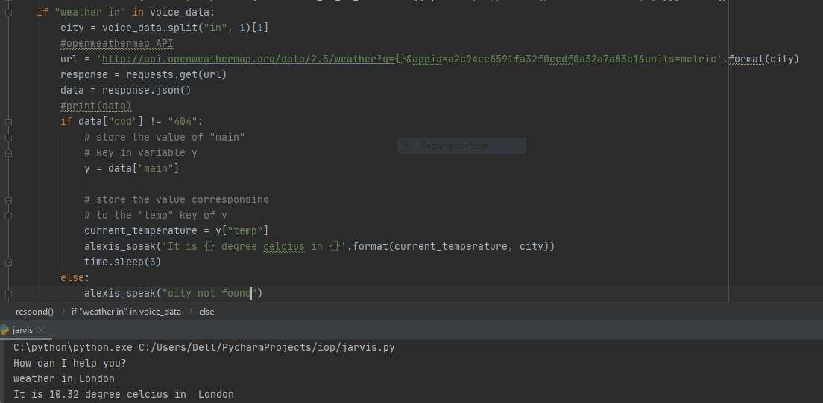

* + **Play music**: This will play songs from the systems library**.** It uses **OS(Miscellaneous operating system interfaces) library** in python. This library provides a portable way of using operating system dependent functionality.

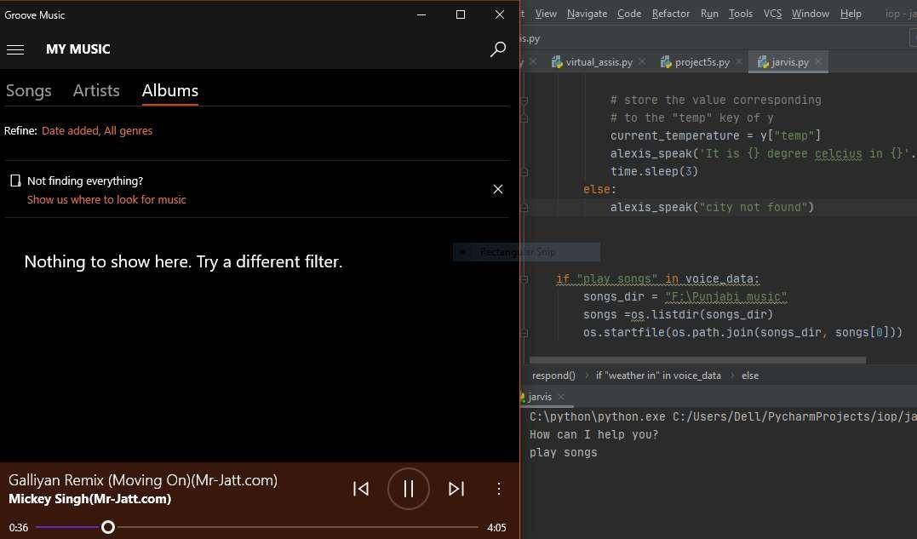

* + **Crawl data:** Function to make the assistant crawl some Wikipedia data and read it for us. For this we can use Wikipedia api from python.

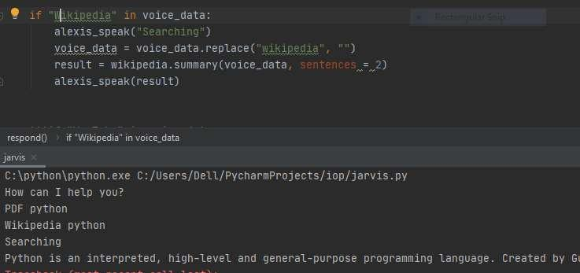

# Output validation and comparison

The output of the project will be the required responses from the assistant when the user gives the command. As compared to other AI agents in market like siri, cortana, google assistant etc Our Alexis is a little slow in giving the output .

Given the fact that there are several failure points, theteststrategyforany AIsystem must be carefully structured to mitigate risk of failure. We mustfirstunderstandthevariousstages in an AIframework. With this understanding, we will be able to defineacomprehensive test strategy with specifictesting techniques across theentire framework. Here are four key AI use cases that must be tested to ensure proper AI system functioning:

* Testing standalone cognitive features such as natural language processing (NLP), speech recognition, image recognition, and optical character recognition (OCR)
* Testing AI platforms such as IBM Watson, Infosys NIA, Azure Machine Learning Studio, Microsoft Oxford, and Google DeepMind
* Testing ML-based analytical models
* Testing AI-powered solutions such as virtual assistants and robotic process automation (RPA)

|  |  |
| --- | --- |
| **Natural language processing (NLP)** | * Testfor‘precision’ return of the keyword, i.e., a fractionof relevant instancesamong the totalretrieved instances of NLP * Test for‘recall’, i.e., a fraction of retrieved instances over total number of retrieved instances available * Testfor true positives (TPs), true negatives (TNs), false positives (FPs), and false negatives (FNs). Ensure that FPs and FNs are within the defined error/fallout range |
| **Speech recognition inputs** | * Conduct basic testing of thespeech recognition software to seeif thesystem recognizes speechinputs * Test for pattern recognition to determine if the system can identify when a unique phrase is repeated several times in aknownaccent and whetherit canidentify the same phrase when it is repeated in a different accent * Test deep learning, the ability to differentiate between ‘New York’ and ‘Newark’ * Test how speech translates to response. For example, a query of “Find me a place I can drink coffee” shouldnotgeneratearesponsewithcoffeeshopsanddrivingdirections. Instead, itshouldpointtoa   public place or park where one can enjoy his/her coffee |

**Applications of Alexis**

1. Our AI assistant can communicate effectively with the user through voice and also prints the commands and it’s response for better understanding.
2. It can perform any search the user requests and hence is helpful for the user.
3. The user doesn’t require to open email and then type long mails, all of this work will be done by Alexis the user just has to say what the subject and body should contain.
4. When the user wants to listen music she just needs to say it and the songs will be automatically played without requiring any physical effort from the user.
5. It has all the current condition about time date ,weather at any place, location of any place the user needs to ask about it and will get all the information needed.

So basically this Assistant will ease all the day to day task of the user and the user will have all the important information without making much effort.

**Team work distribution**

The Listening and responding to user commands, searching web, sending email , checking weather and playing youtube modules were done by the team leader i.e. ADITYA (18BCS6656), SUMIT(18BCS6654)

The searching location, play music, crawling data, greeting user and date and time module were done by BINIT(18BCS6639), SHIVAM (18BCS3054)

All the documentation work was done by the contribution of both teammates.

**Knowledge enhancement:**

We gained a lot of knowledge about AI and python libraries. An AI assistant revolves around two important concepts Natural Language Processing and speech recognition:

* **Natural Language Processing (NLP)** refers to AI method of communicating with an intelligent systems using a natural language such as English.

Processing of Natural Language is required when you want an intelligent system like robot to perform as per your instructions, when you want to hear decision from a dialogue based clinical expert system, etc.

The field of NLP involves making computers to perform useful tasks with the natural languages humans use. The input and output of an NLP system can be −

* Speech
* Written Text
* **Speech recognition** is a technology that is empowered by AI to add convenience to its users. This new technology has the power to convert voice messages to text. And it also has the ability to recognize an individual based on their voice command. Hence, this AI- powered speech recognition technology gained mammoth importance among tech giants such as Apple, Microsoft, Amazon, Google, Facebook, etc.

Other than these two concepts we also learned about many python libraries and their functions. Some of them are Explained below:

* **gTTS (*Google Text-to-Speech*)->**It is a Python library and CLI tool to interface with

Google Translate’s text-to-speech API. Writes spoken mp3 data to a file, a file-like object

(bytestring) for further audio manipulation, or stdout . It features flexible pre-processing

and tokenizing, as well as automatic retrieval of supported languages.

* **SeleniumLibrary** is a web testing library for Robot Framework that utilizes

the Selenium tool internally. Selenium Python bindings provide a convenient API to access Selenium Web Driver like Firefox, Chrome, etc.

* The **smtplib** module defines an SMTP client session object that can be used to send mail to any Internet machine with an SMTP or ESMTP listener daemon.
* The **OS** module in python provides functions for interacting with the operating system. OS, comes under Python’s standard utility modules. This module provides a portable way of using operating system dependent functionality. The *os* and *os.path* modules include many functions to interact with the file system.

Other libraries used are Wikipedia, playsound, date and time, webbrowser etc.